**CHAPTER ONE**

**INTRODUCTION**

**1.1 Background of the Study**

In recent years, Spider Radio, a prominent radio station within our institution, has garnered significant popularity among students from diverse departments. The increasing demand for Spider Radio's broadcasts highlights the necessity for a contemporary approach to news dissemination. While traditional broadcasting methods have been the standard, the digital age has ushered in new expectations, with students favoring web-based news delivery for its accessibility and convenience. As the hunger for instantaneous access to news continues to grow, our institution recognizes the urgency of adapting to web-based platforms for optimized news distribution. This transition to a digital-first strategy aligns with the evolving media landscape and presents an opportunity to create a more engaging and user-friendly platform, ensuring that students can easily stay informed about current affairs. The News Feed Application System, the focus of this project, aims to bridge the divide between Spider Radio's traditional broadcasting and the dynamic expectations of students in this digital era. Chhabria et al. (2022).

In today's rapidly changing world, the consumption of news has been significantly reshaped, with digital platforms serving as central conduits for accessing and disseminating information. This transformation is particularly evident within our institution, where students have embraced Spider Radio as a valuable source of on-air broadcasts. Nevertheless, in the era of smartphones and instant connectivity, there is a growing need to modernize the delivery of news content to accommodate the preferences and expectations of our student body. The News Feed Application System, the core of this project, represents a contemporary and adaptable solution designed to bring Spider Radio's news broadcasts closer to students. It is structured to provide a user-friendly, hassle-free means for students to access news through images and headlines, recognizing the busy lives they lead and their desire for prompt access to current affairs. By embracing this digital transition, we aim to enrich the student experience by making news more accessible, interactive, and engaging. Rugveda et al. (2018)

This project is a journey into the development of a web-based news feed application, ensuring that Spider Radio's news remains at the forefront of information dissemination within the institution. As students navigate their daily routines, this application empowers them to stay updated with the latest news developments with just a simple click. Through this endeavor, we aim to bridge the gap between traditional radio broadcasting and the ever-evolving expectations of our student community, ultimately enriching the educational experience and fostering a more informed student body. Rugveda et al. (2018)

**1.2 Statement of the Problem**

Spider Radio News has gained immense popularity among students from various departments at the institution. As this trend continues to grow, there is a pressing need to develop a cutting-edge and versatile News Feed Application System tailored to facilitate students' access to news content conveniently. The problem at hand is to develop an efficient News Feed Application System that optimizes students' engagement with Spider Radio news, enhancing accessibility, interactivity, and overall user experience within the institution.

**1.3 Aim and Objectives of the Study**

**This project aims to develop a web-based news feed system for Kadpoly Spider Radio** by providing a user-friendly platform for accessing news through images and headlines. **The objectives are as follows:**

1. To design a web-based news feed system.
2. To reveal the related literature on web-based news feed systems.
3. To implement the system and evaluate his efficiency in terms of system information needs / output.

**1.4 Scope of the Study**

The scope of this study encompasses the development of a comprehensive web-based news feed system specifically tailored for Kadpoly Spider Radio. The system will focus on providing a user-friendly platform that enables students to conveniently access news content through a combination of images and headlines. It will cover the design, implementation, and evaluation phases of the News Feed Application System and will not including commenting and sharing of new.

**1.5 Limitations of the Study**

This study's scope has been constrained by several issues, including:

**Time** - The researcher's busy academic pursuits severely limited the time allotted for research for this study.

**Finance** - The need for a standard working personal computer unit to execute and debug the application software, hindered the quick and simple progress of the task.

**1.6 Significance of Study**

This study's significance lies in its potential to modernize news delivery at the institution. By introducing a user-friendly News Feed Application System for Spider Radio, it addresses the need to adapt to digital platforms and meet students' evolving expectations. The system ensures quick access to news, bridging the gap between traditional radio and students' dynamic preferences. This enhancement in accessibility and interactivity aims to keep students well-informed and foster a more engaged campus community.

**1.7 Project Organization**

The project is divided into five chapters. The outlines are presented below:

**Chapter One: Introduction**

Chapter one introduces this project work, the background of the study, the statement of the problem, the aim and objectives, the scope of the study, limitations of the study, the significance of the study, project organization, and the definition of terms.

**Chapter Two: Literature Review**

This chapter focuses on the literature review, and the contributions of other scholars on the subject matter being discussed.

**Chapter Three: Methodology and Design**

This chapter is concerned with the presentation of the results of system analysis and design. It presents the research methodology used in the development of the system to facilitate an understanding and effective future implementation of the system.

**Chapter Four: System Implementation Evaluation**

This chapter describes the system implementation and documentation, analysis of modules, and system requirements for implementation.

**Chapter Five: Summary, Conclusion, and** **Recommendation**

The chapter provides a summary of major findings, conclusions, and recommendations based on the study conducted.

**1.8 Definition of Terms**

1. **Interactivity:** Interactivity refers to the level of engagement and two-way communication facilitated within the News Feed Application System.
2. **Mobile-based:** The term "web-based" denotes a system, application, or platform that operates through the internet or an intranet, accessible via web browsers**.**
3. **User interface (UI):** The part of a software application that the user interacts with, including the layout, buttons, and other elements**.**
4. **User experience (UX):** The overall experience of a user interacting with a product or service, including their emotions, perceptions, and behaviours**.**

**CHAPTER TWO**

**LITERATURE REVIEW**

**2.1 Introduction**

This chapter seeks to explain how the topic under research relates to prior research, current practice, or other areas of knowledge by citing relevant works by other scholars that have addressed a related issue. Furthermore, this chapter will present a synthesis of current research on the topic, highlighting areas of agreement, disagreement, and gaps in the literature, to demonstrate the project topic's relevance in the field and to recommend opportunities for future research.

**2.2 Literature Review**

Chhabria, Dekate, Thakre, Waghaye, Bondade, & Narwade (2022) recently made research on OpenJ – The News Application. This work underscores the integral role of journalism in the interconnected web of global information. It emphasizes how journalism is not merely a mode or type but a comprehensive system that harnesses the power of collective information sharing. Open journalism leverages the capacity for anyone to publish and collaborate, offering a richer understanding of the world. The study also highlights how technology and mobile platforms play a pivotal role in disseminating news and engaging a wider audience.

Furthermore, the methodology of this study primarily centers on the utilization of specific tools for the development of a News App aimed at providing 100% verified news content. The choice of tools includes the Flutter framework, known for its prowess in mobile application development, powered by the Dart programming language, which seamlessly integrates with Flutter. Additionally, Google Firebase serves as the core backend infrastructure, functioning as a Backend-as-a-Service (BaaS) platform. These tools collectively ensure the efficient and reliable operation of the News App.

In conclusion, the successful development of OpenJ – The News Application, which has initially focused on Android users, a key recommendation is to expand the application's accessibility to users on various platforms. It is recommended to investigate and implement a cross-platform solution to maximize the reach and impact of the news application, ultimately creating a more universally accessible news source. One notable research gap lies in the scope of platform accessibility. There is an opportunity to develop a more inclusive approach by creating a news application that caters to users across various platforms. By extending the reach to iOS, web-based, and other platform users, the application can offer a more comprehensive and versatile news delivery service.

Shabnammakandar & Snehal (2018) recent student on A Location and Diversity-Aware Optimized News Feed System for Android Users. This paper introduces D-MobiFeed, a novel Location-Aware News Feed (LANF) system designed to cater to mobile users' spatial and non-spatial preferences. Unlike traditional LANF systems that primarily send geo-tagged messages, D-MobiFeed prioritizes diversity within news feeds to help users explore new places and activities. To achieve this, the system employs the Maximum Likelihood Algorithm to predict the user's future location and retrieves the most relevant messages using semantic ontology. This innovative approach promises to enhance the user experience by delivering more diverse and contextually relevant news feeds.

Moreover, the methodology used in this study involves the use of specific tools and technologies, such as the Maximum Likelihood Algorithm, Android Studio 2.1.2 for application development, Java 1.7 for coding, the Xampp Control Panel v3.2.2 for database management, and the Apache Tomcat Server for web hosting. These components collectively enable data analysis, prediction, and the creation of an Android-based application, ensuring compatibility across different platforms and optimizing system performance.

In conclusion, the development of D-MobiFeed, a location-aware news feed framework that combines relevance and diversity in scheduling news feeds for mobile users, is a commendable step toward enhancing the user experience. To further enhance this framework, it is recommended to consider the implementation of user sharing features, allowing users to share posts and information with others, thereby fostering community engagement and information dissemination.

A notable research gap lies in the exploration of user-sharing features within D-MobiFeed, which could significantly enrich the framework's functionality by promoting content sharing and collaboration among users. This aspect presents an opportunity for future research and development. Furthermore, there is room for research into enhancing the framework's cross-platform compatibility, as the paper alludes to the potential for D-MobiFeed to support operating systems beyond Android.

Arpit & Poornalatha (2022) recently made a research on an Online News Feed Data Mining and Prediction. This paper revolves around the significance of data mining and prediction systems, particularly in the context of enhancing performance and revenue generation for IT companies. The focus is on the development of an Online News Feed Prediction System that analyzes and compares various prediction techniques through different methods of implementation. Utilizing a dataset from the UCI repository, which includes news topics, sentiment analysis, publication dates, and popularity scores on social media platforms, the study employs Python, R, and Weka for data preprocessing, visualization, and prediction techniques such as Random Forest, Decision Tree, and SVM. Additionally, the paper explores the analysis of social media platform scores at regular intervals, offering insights into audience reach. This research not only serves as a valuable resource for improving news agencies' profitability and visibility but also strives to uncover effective methodologies for achieving these results.

However, in this study, the methodology involves the utilization of Python, specifically employing functions like OneHotEncoder and qcut from the preprocessing and pandas libraries, to process the News final dataset. To gain a comprehensive understanding of the data and transform it into meaningful information, a combination of Weka, R, and Python is used to create various graphical representations, including q-q plots and box plots. These visualizations serve to enhance data analysis and provide valuable insights into the research objectives.

In Addition, this study's recommends the importance of selecting the right algorithms, such as Support Vector Machine, for accurate predictions in news feed topics. It also emphasizes the platform-specific influence on popularity scores and suggests that news agencies should consider this when publishing articles. The sentiment analysis results offer valuable insights for content engagement, and news agencies can use this information to improve their reach and impact. In the future, research can explore additional attributes like publishing time and use feedback datasets to enhance prediction models further.

In conclusion, a potential area for future research lies in the inclusion of attributes such as publication time to improve prediction accuracy. Additionally, exploring the use of feedback datasets for grouping attributes and identifying common patterns offers opportunities for refining predictive models and gaining a deeper understanding of article engagement. Investigating these aspects can contribute to more precise predictions and better-informed publishing strategies.

Rugveda, Harshavardhan, Arun, & Sathish (2018) performed a study on News Feed Application for Android. The "News Feed Application for Android" project addresses the growing demand for mobile news applications, providing a cutting-edge and versatile solution for users worldwide. This Android-based news application offers an easy and hassle-free means of staying connected with the world through images and headlines. The user-friendly interface makes it simple to use, and it can be easily downloaded. In the fast-paced, modern lifestyle, users can access essential current affairs with just a click, making it a valuable tool for staying informed about daily society events and news.

Moreso, the methodology involves API integration, particularly RESTful services, and the use of Google's new API. The project employs a dual database system, combining MySQL Server and MongoDB for enhanced data retrieval. MySQL Server stores user information, news feeds, and keywords. The Android application with the database is hosted on separate servers, offering various user interfaces for web, Android OS, iOS, and Windows Mobile. This approach adds flexibility and shifts some functionalities to the client side, where HTML5 and JavaScript are used for development, with frameworks facilitating application creation for iOS and Android using HTML5. This approach maximizes versatility and accessibility.

In conclusion, as the project leverages HTML5 and JavaScript for client-side development, it would be beneficial to continually evaluate and incorporate the latest web technologies and frameworks to stay at the forefront of mobile application development. One notable research gap is the need for in-depth exploration of the performance and scalability of the dual database system, particularly in large-scale applications. This gap offers an opportunity for future research to assess the system's efficiency and reliability as the volume of data and users increases.

Dhiman (2019) made a research on the Effects of Online News Applications for Android–A Critical Analysis. This research paper delves into the realm of mobile news applications, commonly known as news apps, designed for smartphones, tablets, and iPads, with a primary focus on Android devices. These apps, readily available on Google Play Store, offer users access to a wide range of news genres, from breaking news to entertainment updates. The study aims to assess the utility of these Android news applications, particularly those available for free, by conducting in-depth interviews with 50 research scholars. The research seeks to ascertain whether these apps genuinely serve as valuable resources for users seeking current updates and breaking news, raising questions about their overall impact and usefulness for mobile users.

Furthermore, the research methodology adopts a focus group approach involving 50 Research Scholars who regularly use Android news applications. This cohort comprises 25 MPhil scholars and 25 PhD scholars from various departments. The predominant choice among these scholars is UC News, which is available in English and Hindi, tailored for the Indian audience. Out of the 50 users, 40 favor the Hindi version, with 30 being PhD scholars and 10 MPhil scholars, while the remaining 10 opt for the English language version. This methodology seeks to gather insights into user preferences and experiences regarding news applications and language choices.

In conclusion, the study suggests developers should prioritize providing current updates and entertainment news, considering the strong user demand for these content types. It's important to maintain the perception of these apps as free of cost while exploring sustainable revenue models. Developers can also address health issues and negative impacts by promoting responsible usage. Ensuring content authenticity and reliability is crucial to enhance the user experience.

**2.3 Summary of Related Literature Reviews**

|  |  |  |
| --- | --- | --- |
| **Author & Year** | **Title & Description** | **Merit and Demerits** |
| Chhabria et al. (2022) | OpenJ – The News Application.  This work underscores the integral role of journalism in the interconnected web of global information. It emphasizes how journalism is not merely a mode or type but a comprehensive system that harnesses the power of collective information sharing | The merit of the project lies in its innovative approach to news dissemination through OpenJ  System focus on Android users, creating a platform-specific limitation that may hinder inclusivity |
| Shabnammakandar & Snehal (2018) | A Location and Diversity-Aware Optimized News Feed System for Android Users.  This paper introduces D-MobiFeed, a novel Location-Aware News Feed (LANF) system designed to cater to mobile users' spatial and non-spatial preferences. | It prioritizes spatial and non-spatial preferences, using a Maximum Likelihood Algorithm.  The limitation is its current exclusivity to Android |
| Arpit & Poornalatha (2022). | Online News Feed Data Mining and Prediction.  This paper revolves around the significance of data mining and prediction systems, particularly in the context of enhancing performance and revenue generation for IT companies | It provides valuable insights for improving news agencies' profitability and visibility.  The limitation is the exclusion of attributes like publication time, suggesting a need for future research |
| Rugveda et al. (2018) | News Feed Application for Android.  The "News Feed Application for Android" project addresses the growing demand for mobile news applications, providing a cutting-edge and versatile solution for users worldwide. | The system offered a user-friendly interface and a dual database system for enhanced data retrieval and flexibility across various platforms.  The system needs to incorporate the latest web technologies to ensure the project stays at the forefront. |
| Dhiman (2019) | Effects of Online News Applications for Android–A Critical Analysis.  This research paper delves into the realm of mobile news applications, commonly known as news apps, designed for smartphones, tablets, and iPads, with a primary focus on Android devices | The project shed light on user preferences and emphasizing the importance of providing current updates and entertainment news.  The project limitation lies in the focus of a specific user group (research scholars), which may limit the generalizability of the findings. |

**2.4 Analysis of the Current System**

The current system, centered around Spider Radio's traditional broadcasting methods, has witnessed a surge in popularity among students within the institution. However, with the evolving media landscape and the preference for web-based news delivery, there is a recognized need for a contemporary approach. While Spider Radio has become a valuable on-air source, the current system faces challenges in meeting the instantaneous news access expectations of students in the era of smartphones and instant connectivity. The reliance on traditional methods may result in limitations in accessibility, interactivity, and engagement, prompting the necessity for a digital-first strategy.

**2.4.1 Problem Inherent in** **the Current System**

The inherent problem in the current system lies in its inability to fully align with the dynamic expectations of students. Traditional broadcasting, while successful, falls short in providing the quick, interactive, and accessible news experiences desired by students in the digital age. As the popularity of Spider Radio grows, there is a pressing need to address the limitations of the current system and develop a News Feed Application System. This system should optimize engagement, enhance accessibility, and offer a more user-friendly platform to ensure that Spider Radio remains at the forefront of information dissemination within the institution

**2.5 Analysis of the Proposed System**

The proposed News Feed Application System represents a forward-thinking response to the evolving media landscape and the preferences of students at our institution. Positioned as a bridge between Spider Radio's traditional broadcasting and the expectations of the digital era, the system aims to enhance accessibility, interactivity, and overall user experience. By leveraging web-based platforms and offering a user-friendly interface with images and headlines, the proposed system addresses the growing demand for instantaneous access to news content. The focus on a contemporary and adaptable solution aligns with the institution's goal of staying at the forefront of information dissemination. The proposed system not only recognizes the busy lives of students but also aims to enrich their educational experience by making news more accessible, interactive, and engaging. Overall, the system presents a strategic and timely initiative to ensure Spider Radio remains a valuable and modern source of information within the institution.

**CHAPTER THREE**

**METHODOLOGY AND DESIGN**

**3.1 Introduction**

A methodology is a process of rigorous study or inquiry, particularly to unearth new facts or information; hence, research methodology should be good enough to enable the achievement of the specified objectives which are achievable using specific components, such as data collection and design procedures and system modeling (use case, activity, and class diagrams). This chapter contains the input/output specifications, and system requirements for the development of **a web-based news feed system for Kadpoly Spider Radio**.

**3.2 Method of Data Collection**

Before developing any system, collecting data and facts about the existing system is critical to understand what is going on. This research was carried out using two methods.

1. Observation of the Work Environment
2. Documentation

**3.2.1 Observation of the Work Environment**

This method was employed to acquire information and data for this study by monitoring how the manual system worked. The most evident flaws in the existing system were discovered via detailed inspection. Using the observational approach, the context in which the observation is made can be modified in a variety of ways.

**3.2.2 Documentation**

Documentation is a type of secondary data collection. This method makes use of journals, manuals, past work, publications, and other sources. This method of data collection is used because it allows for comparison with past studies. This includes the internet, which is a data collection tool. The internet was used to find information on difficult or ambiguous issues.

**3.3 System Modeling**

A system model is a conceptual model of a system that explains and represents it. A system is any interaction between a set of components that work together to achieve a common purpose. Visual models of object-oriented software-intensive systems may be created utilizing a set of visual notation techniques included in the Unified Modeling Language, which is used in the creation of this contemporary system. UML diagrams utilized in this new design include use case diagrams, class diagrams, and activity diagrams.

**3.3.1 Use Case Diagrams**

Use cases are collections of system-to-user interactions. Use case diagrams are used to graphically characterize the functionality of a system in terms of its actors, goals (represented as use cases), and dependencies between those use cases.

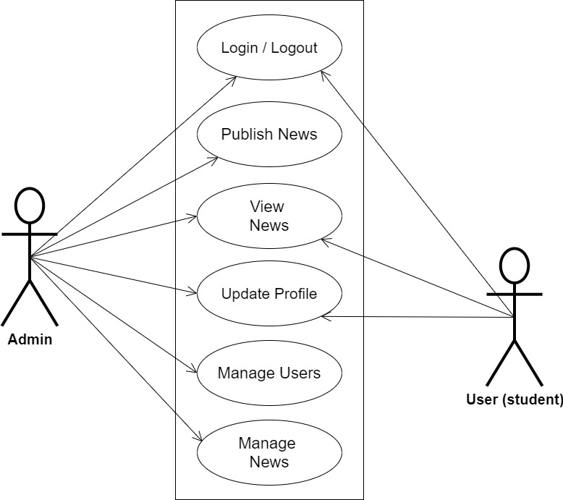

**Figure 3.1 System Use Case Diagram**

**3.3.2 Class Diagrams**

The Unified Modeling Language (UML) class diagram is an implementation of an independent perspective of how the system interface would look, with each class having its own set of attributes and demonstrating how they interact with one another. Class diagrams employ the Unified Modeling Language standards to visually portray a given system's static structure and composition (UML).

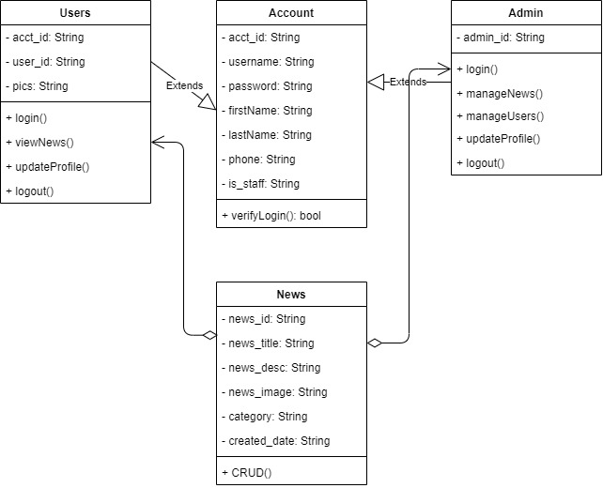

**Figure 3.2 System Class Diagram**

**3.3.3 Activity Diagrams**

An activity diagram, like a flowchart or a data flow diagram, visually illustrates a series of events or the flow of control in a system, but it acts more like an enhanced version of both.

**Login**

The process for gaining access to the system is depicted in the diagram below; the email address and password must be accurate to gain access.

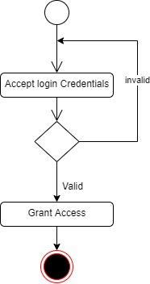

**Figure 3.3 Login Activity Diagram**

**Publishing News**

The process for publishing a news for other users to view is depicted below, to publish a news one has to be authenticated and must have proper authorization

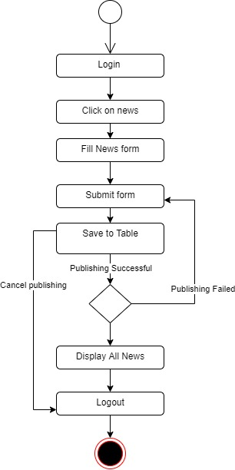

**Figure 3.4 Publishing News Activity Diagram**

**3.4 Database Design**

The logical explanation of how data is kept in the computer's memory is called input specification. The freedom experienced in using the system, as well as the convenience of retrieving and reading the data and assuring applicability across the internet, make SQL standards essential for ensuring that structured data is uniform and independent of applications. Some of the input specifications employed in this project work are presented below.

1. Account Table: contains basic information about all system users.
2. News Table: contains every system-saved location information.

**Table 3.1 Account Input Specification Table**

|  |  |  |  |  |  |
| --- | --- | --- | --- | --- | --- |
| **Field Name** | **Data Type** | **Null** | **Key** | **Length** | **Description** |
| acct_id | Varchar | No | PK | 32 | Unique string for identifying users |
| username | Varchar | No |  | 100 | Username |
| password | Varchar | No |  | 128 | User Password |
| firstName | Varchar | No |  | 60 | User first name |
| lastName | Varchar | No |  | 60 | User last name |
| phone | Varchar | No |  | 20 | User type (student/others) |
| is_staff | Bool | No |  | 100 | Denotes if the user is an admin |

**Table 3.2 News Input Specification Table**

|  |  |  |  |  |  |
| --- | --- | --- | --- | --- | --- |
| **Field Name** | **Data Type** | **Null** | **Key** | **Length** | **Description** |
| news_id | Varchar | No | PK | 32 | Unique string identifying news |
| news_title | Varchar | No |  | 60 | Title of the news |
| news_desc | Varchar | No |  | 100 | News Description |
| news_image | Varchar | No |  | 100 | News image |
| category | Double | No |  | 128 | Category of the news |
| created_date | Date | No |  | 20 | Creation date |

**3.5 Output Design**

This declares and displays the outcome of the given input. This automated system's output is dependent on its input. The output specification is listed below.

**Table 3.3 Account** **output design table**

|  |  |  |  |  |  |  |
| --- | --- | --- | --- | --- | --- | --- |
| **User_id** | **Username** | **Password** | **FirstName** | **LastName** | **Phone** | **Is_staff** |
| XXXX | XXXX | XXXX | XXXX | XXXX | XXXX | XXXX |
| XXXX | XXXX | XXXX | XXXX | XXXX | XXXX | XXXX |
| XXXX | XXXX | XXXX | XXXX | XXXX | XXXX | XXXX |
| XXXX | XXXX | XXXX | XXXX | XXXX | XXXX | XXXX |

**Table 3.4 News** **output design table**

|  |  |  |  |  |  |
| --- | --- | --- | --- | --- | --- |
| **News_id** | **News_title** | **News_desc** | **News_image** | **Category** | **Created_date** |
| XXXX | XXXX | XXXX | XXXX | XXXX | XXXX |
| XXXX | XXXX | XXXX | XXXX | XXXX | XXXX |
| XXXX | XXXX | XXXX | XXXX | XXXX | XXXX |
| XXXX | XXXX | XXXX | XXXX |  | XXXX |

**3.6 Input & User Interface Design**

This is a graphic depiction of the system interface; it will be designed to be user-friendly, responsive, and visually beautiful. Furthermore, it will be fully secured, thus authentication will be required to see various levels of the information. To help with the designs, a mid-fidelity wireframing program called Draw.io is employed.

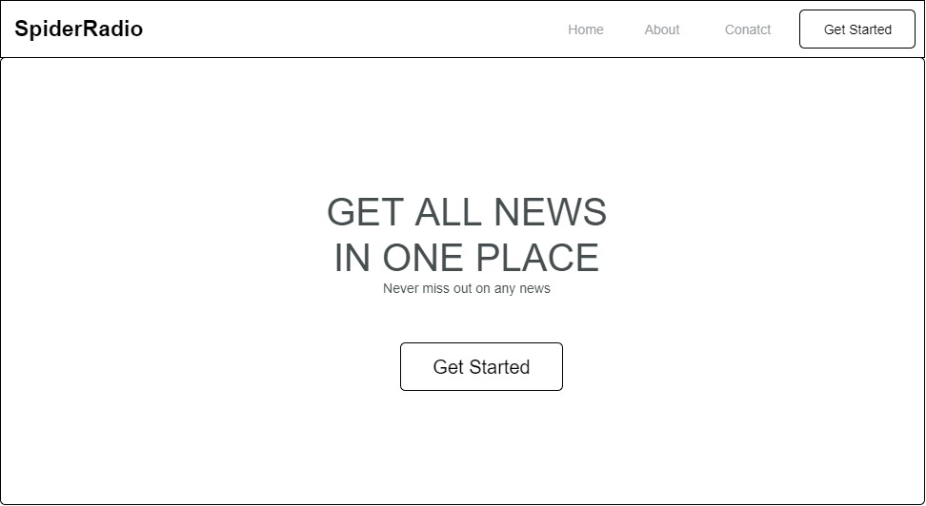

**Figure 3.5 SpiderRadio Home Page**

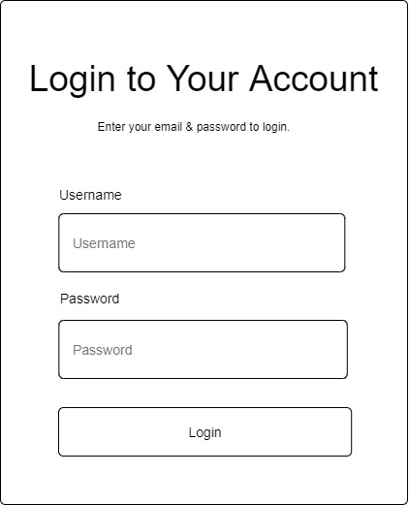

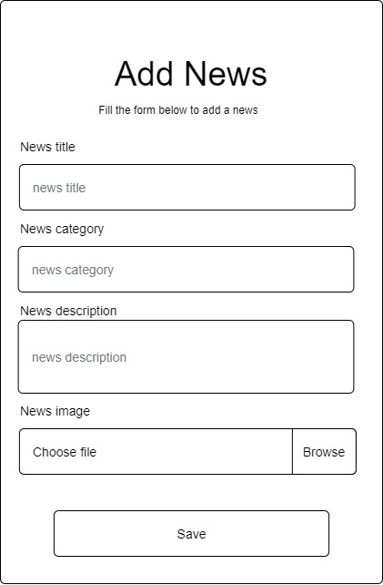**Figure 3.6 User Login Screen**

**Figure 3.7 Add News Screen**

**3.7 System Requirement**

Every piece of software has predefined system requirements that it must fulfill to function properly. The system requirements, on the other hand, are the bare minimum of hardware and software required for the system's intended operation.

**3.7.1 Hardware Requirement**

System Hardware requirements include:

1. Minimum of 2 GB of RAM (Random Access Memory).
2. Minimum of Intel Dual core processor.
3. Minimum of 250GB HDD (Hard Disk Drive).

**3.7.2 Software Requirement**

The software requirements include:

1. At least windows 7 OS (Operating System).
2. Vs. Code IDE installation.
3. Browsers include Chrome and Firefox.

**3.8 Choice of Programming Language**

This research work will be a web-based application and will be implemented on a relational database system (SQLite). HTML (hypertext markup language), CSS (cascading style sheet), and JavaScript for the frontend development while Django (Python) will be employed for the backend programming.

**REFERENCES**

Arpit, G., & Poornalatha G. (2022). Online News Feed Data Mining and Prediction. International

Journal of Innovative Technology and Exploring Engineering, 2278-3075

Chhabria, Dr. S., Dekate, C., Thakre, D., Waghaye, G., Bondade, S., & Narwade, S. (2022). OpenJ

– The News Application. International Journal for Research in Applied Science and Engineering Technology, 10(12), 1086–1090. https://doi.org/10.22214/ijraset.2022.47709

Dhiman, B. (2019). Effects of Online News Applications for Android–A Critical Analysis.

European Journal of Business and Social Sciences.

Rugveda, I., M., Harshavardhan, K., Arun, R., B., & Sathish., K. (2018). News Feed Application

for Android. Journal of Network Communications and Emerging Technologies 8(4).

Shabnammakandar & Snehal P. (2018). A Location and Diversity-Aware Optimized News Feed

System for Android Users. Proceedings of International Conference on Advances in Computer Technology and Management, 2454-7875